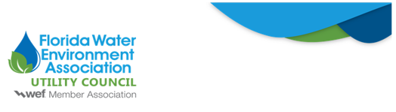

To: FWEA Utility Council
From: David Childs
Re: State Legislation Would Require Utilities to Test Their Biosolids for PFAS
Date: January 7, 2026
House Bill 1019 (by Rep. Conerly) and Senate Bill 1230 (by Sen. Harrell), both titled Perfluoroalkyl and Polyfluoroalkyl Substances, were filed this week ahead of the 2026 Florida Legislative Session. These bills are identical companion measures addressing environmental and public health concerns related to perfluoroalkyl and polyfluoroalkyl substances (commonly referred to as PFAS).
Specifically, the legislation:
- Prohibits, beginning on future staggered dates, the use, sale, purchase, distribution, possession, and use of aqueous film-forming foam containing PFAS, as defined in the legislation.
- Requires the Florida Department of Environmental Protection (FDEP) to develop disposal rules, maintain a registry of foam alternatives, and offer technical and financial assistance.
- Establishes new monitoring requirements for “public entities disposing of domestic wastewater biosolids that have a designed average daily flow of 25,000 or more gallons per day;” these entities would be required to conduct annual PFAS sampling and submit results to the relevant state department.
Notably, the biosolids monitoring requirement does not establish regulatory thresholds for PFAS; instead, it only requires that the “sampling must be conducted in accordance with department rules adopted under s. 403.0855,” i.e. the FDEP’s Biosolids Rule 62-640, F.A.C. The FDEP Biosolids Rule currently does not appear to address sampling for PFAS in biosolids, which means that the Department would likely need to engage in rulemaking to establish sampling protocols.
If you have any concerns regarding this legislation, please do not hesitate to contact David Childs at David@ballardpartners.com.

