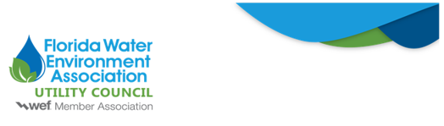

To: FWEA Utility Council
From: David Childs
Re: FDEP Proposes Significant Updates to Septic Tank Rules
Date: December 1, 2025
The Florida Department of Environmental Protection (FDEP) recently released draft rule updates addressing all aspects of onsite treatment and disposal system (OSTDS) regulation, including requirements for permit application processing, installation and location of an OSTDS, abandonment of an OSTDS, construction materials, standards for tanks, registration of a septic tank or a master septic tank contractor, renewal of registration certificates, disciplinary standards and penalties for registered persons, certification of partnerships and corporations, and fees related to OSTDS regulations. Notably, these updates for the first time would require an OSTDS construction permit application to include “documentation of sewer availability,” which should help avoid scenarios where septic tanks are installed in areas that could be served by centralized collection and treatment systems. Draft Rule 62-6.004(3)(g), F.A.C.
On Friday, December 5, 2025, at 1:00 pm EST, FDEP is hosting a public workshop virtually and in person at the Bob Martinez Center, 2600 Blair Stone Road, Room 609, Tallahassee, FL, 32399. If you would like to monitor the workshop via webinar, you will need to first register here.
We will monitor this rulemaking. Should you have any questions or concerns, please do not hesitate to contact me at david@ballardpartners.com.

